Created repository saved as hello-world

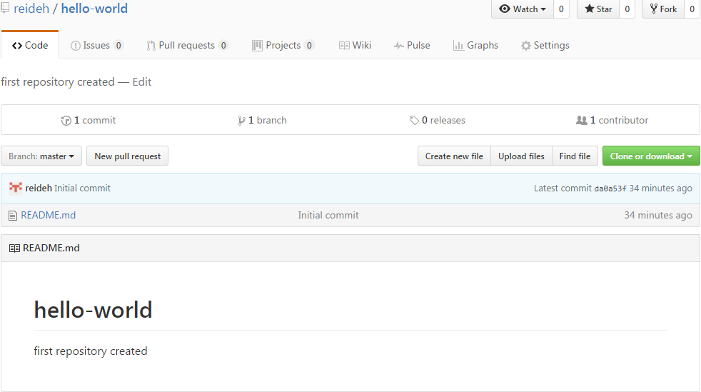

2) Answer the questions by implementing the code and run it.

1. What will the output be from the following code?

num = 4

num*=2

num1=num+2

num1+=3

print(num1)

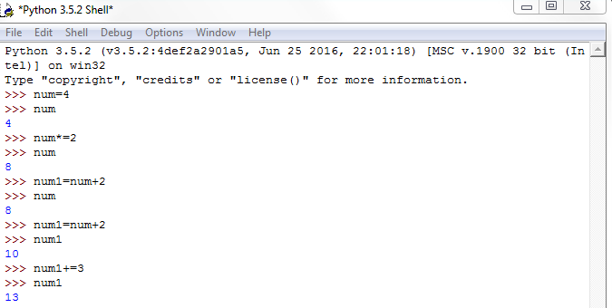

1. What do the following lines of code output? Why do they give a different answer?

print(2 / 3)

print(2 // 3)

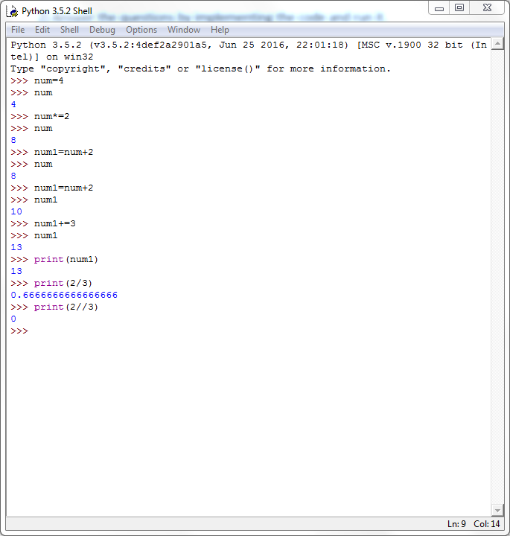

The codes outputs give different outputs because print (2/3) gives the total number for example 0.66666 as shown above and print(2//3) gives the whole number no decimal places as also shown on the above diagram.

3) All of the variable names below can be used. But which of these is the better variable name to use?

A a Area AREA area areaOfRectangle AreaOfRectangle

Answer:

a,area and areaOfRectangle all are the better variable names to use because variable name start with lower case letter at the beginning.

4) Which of these variables names are not allowed in Python? (More than one might be wrong.)

apple APPLE Apple2 1Apple account number account_number account.number accountNumber fred Fred return return_value 5Return GreatBigVariable greatBigVariable great_big_variable great.big.variable

Answer:

1Apple, account number, account. number, return, 5Return and great.big.variable are wrong variable names.